**Case Study**

The main list view is this:

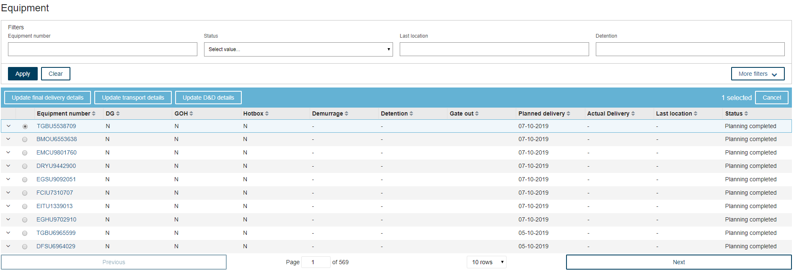

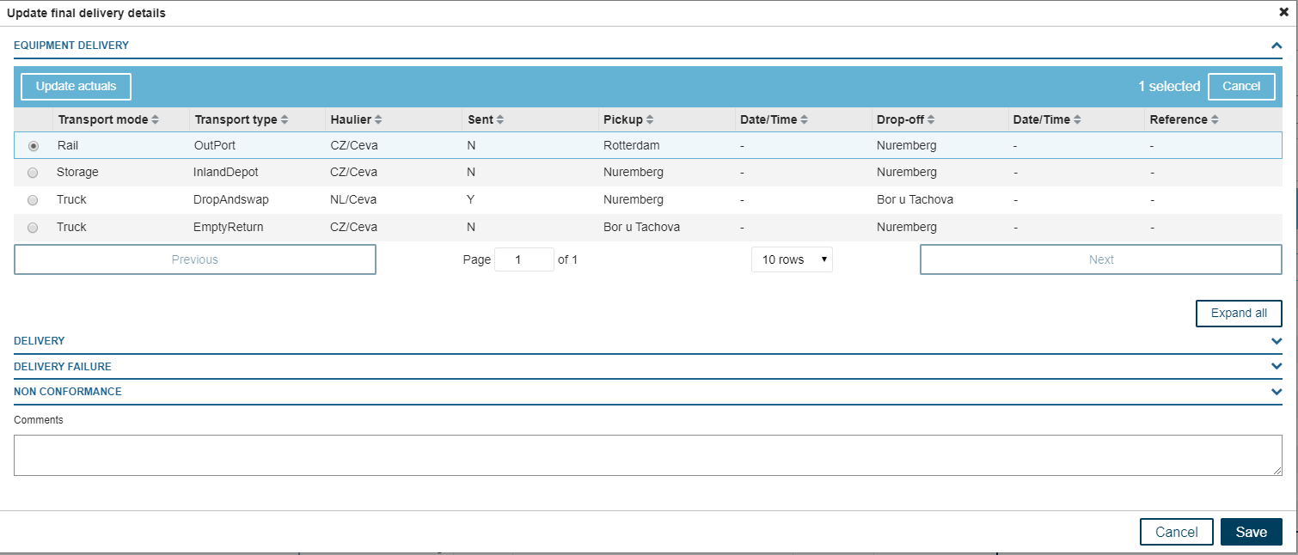

Clicking “Update actuals” (once a record is selected) will show the below screen:

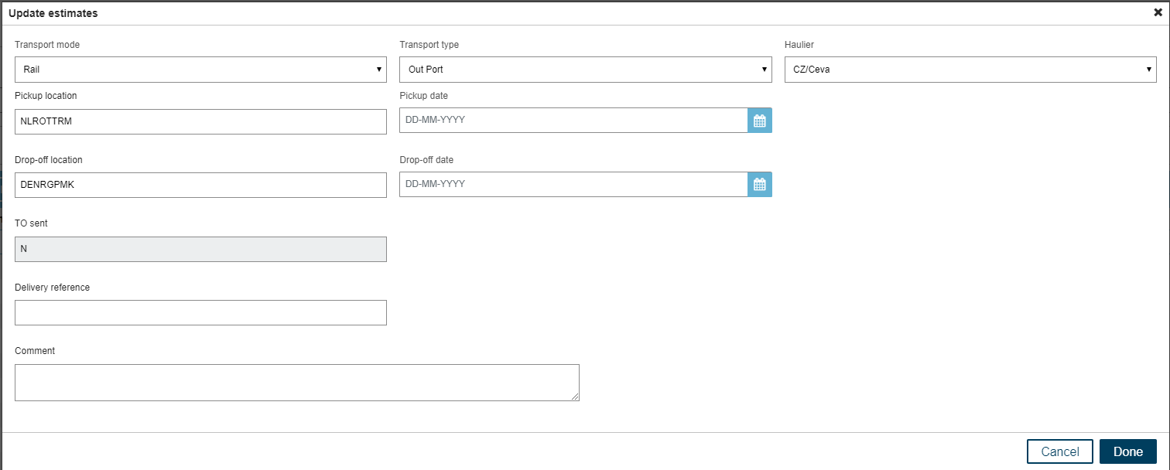

All of these should be available in a bulk upload function

Drop-down values:

1. Transport Mode: Truck, Barge, Rail, Storage
2. Transport Type: transport type are unique per transport mode.

|  |  |
| --- | --- |
| **Transport Mode** | **Transport Type** |
| Truck | Gas check, Fumigation, Inland Depot, Shunt, Out Port, Drop and swap, LiveTip, MilkRun, Empty return, DeRig, Dark Storage |
| Barge | Out Port, Inland Depot |
| Rail | Out Port, Inland Depot |
| Storage | Inland Depot, Dark Storage, Decon Warehouse, DeRig |

1. Haulier: CEVA, Damco, Maritime Transport

Users want to have a bulk upload functionality via an Excel file where they can update or insert multiple records via one Excel file.

We would like to see:

1. How would you write this as a user story/use case/business scenarios?
2. Include acceptance criteria
3. What questions/clarifications do you need to further ask business, if any?
4. Draft Excel template that you would propose to business
5. Provide any comments/suggestions to improve the scenario presented above

You can use MS Word, Notepad, Excel or similar application.